CCT434H5 Design Thinking II
Assignment 1 Write-up
- Reflection and Identification
For this assignment, I would like to examine and investigate the development of retailers. I believe in the new era of the 21st century, things are going to be improved further with various increasingly advanced technologies, including retailers. In addition, I also have interests in restaurants, hotels, and food and beverages, which will be incorporated in this design as well. However, retailers will be my main interest and main focus in this project.
Recently, cashier-less stores are becoming more and more popular in the US and in China. Both countries are showing strong ambitions to develop cashier-less stores as they are trying to lead the industry in the future. For example, Amazon, as America’s retailer representative, officially launched its cashier-less store “Amazon Go” on January 22nd this year. (Horwitz, 2018) China’s BingoBox has launched over 200 cashier-less shops in 29 Chinese cities since 2016.(Horwitz, 2018) Other Chinese competitors like Tencent, Alibaba and SuNing also launch several cashier-less stores in China. (Suning Holdings Group, 2017) I believe this kind of smart stores will dominant the retailer industry in the future, it is truly inspiring to investigate this sector.
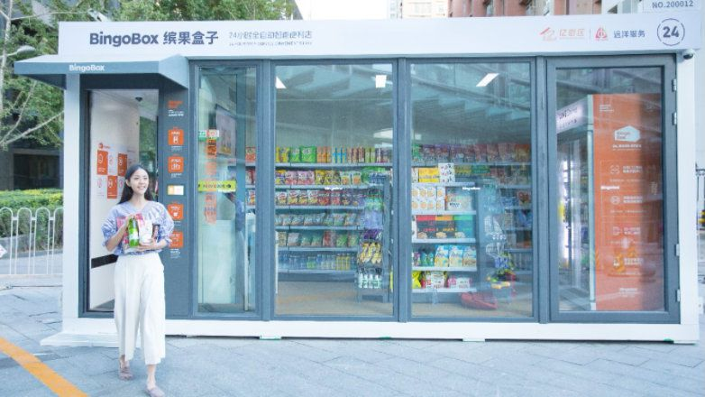 (Horwitz, 2018)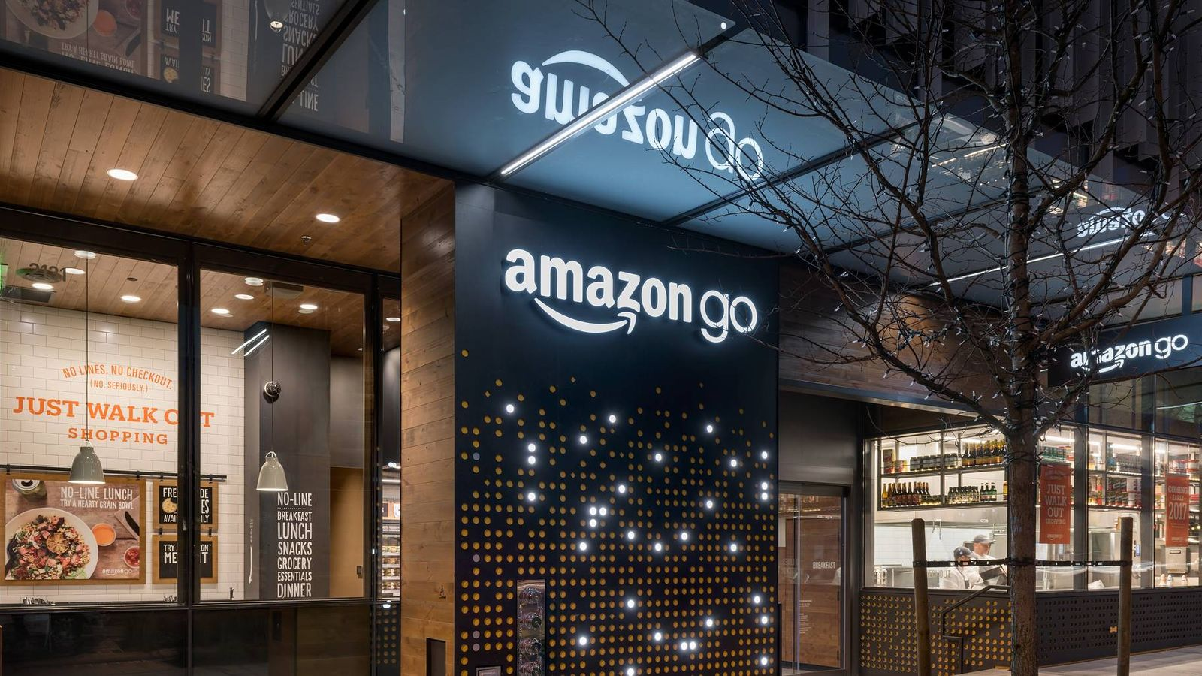 (Statt, 2017)

- Research
History of Retail

Key historical events in retail
1200 BC - The Ancient origins of the retail industry
1300 AD – Renaissance Europe marketplaces
1890 AD – High street hysteria
1910 AD – Self-service and corner store
1930 AD – Mass Modernization culture
1960 AD – The fashion boom of the Swinging Sixties
1970 AD – The dawn of supermarkets
2000 AD – Retail in the digital world
2016 AD – Cashier-less store
(OutsourcedClientSolutions, 2016)

History of Retail Over the past 100 years
Local culture – the Corner Store: 1900s
People went to local corner stores to get the basics with limited choices and the whole shopping activity is also limited by how much people can carry back to their home.

Mass modernization culture – Department store: 1900 – 1940
Thanks to the development of automobiles, people could go further and carry more stuff every time they went shopping. Also, people could stock more things at home because of refrigeration. It was becoming popular to go to department stores.

Suburban culture – Mall: 1950s - 1970s
This was the time of the true mall.

Consolidation culture – Big Box stores: 1970 – 1990
Big Box stores drove a lot of the smaller local merchants out of business.

Digital culture – E-commerce: 1990 – 2013
Actually, E-commerce is still extremely popular currently. This has been the time that online shopping playing a vital role in the retailing industry.

Cashier-less store: 2016- Present
This is the current trend of the retailing industry. The upper-class in the industry would like to lead the industry in a smarter way in the future with less and less employees and cost.
(Leibowitz, 2013)
Present and Future of Cashier-free Store
There are some highlights should be indicated in cashier-free store retailing industry. Although the same goal is for customers to complete an effortless shopping experience and save some costs for the retailers on employment, different companies have different method of operating their systems. For example, SuNing’s method is to apply facial recognition technology, Radio Frequency Identification, Big Data Analysis and its owned online financial services to create an effortless shopping experience (Suning Holdings Group, 2017); whereas Amazon Go’s checkout-free shopping experience is powered by the same strategies and technologies used in self-driving cars: computer vision, sensor fusion, and deep learning. (Amazon, n.d.)

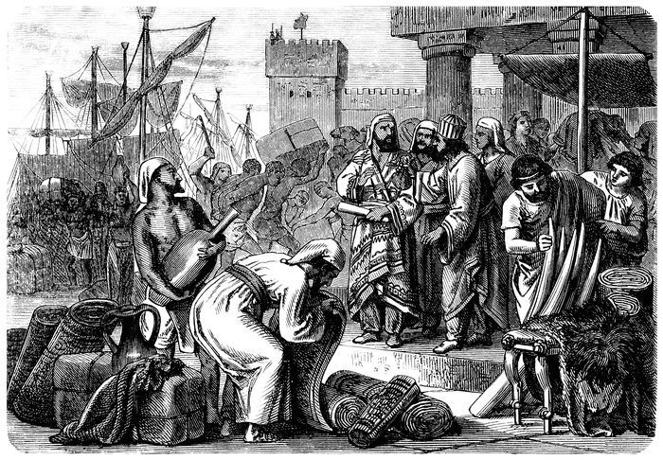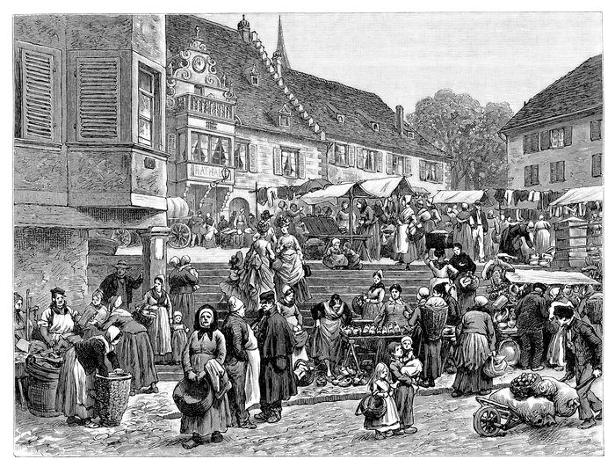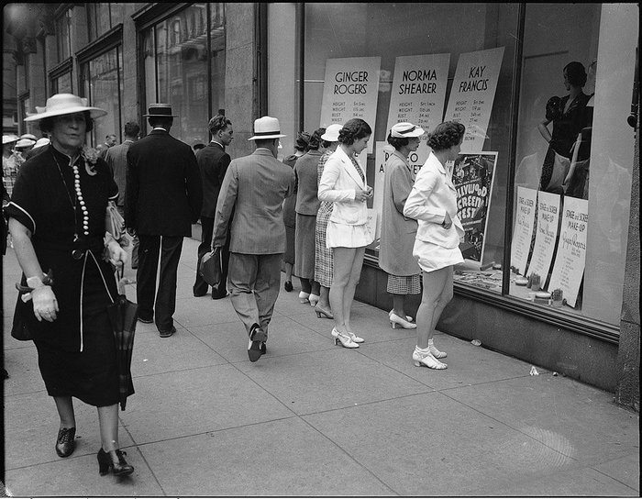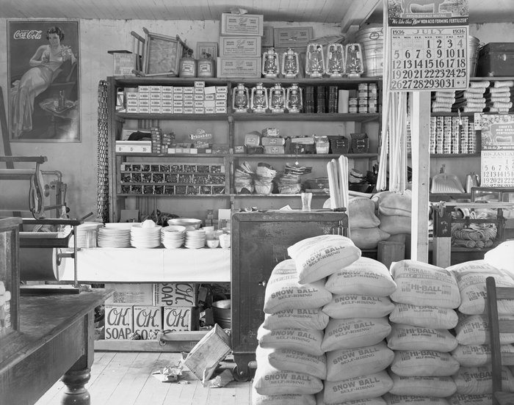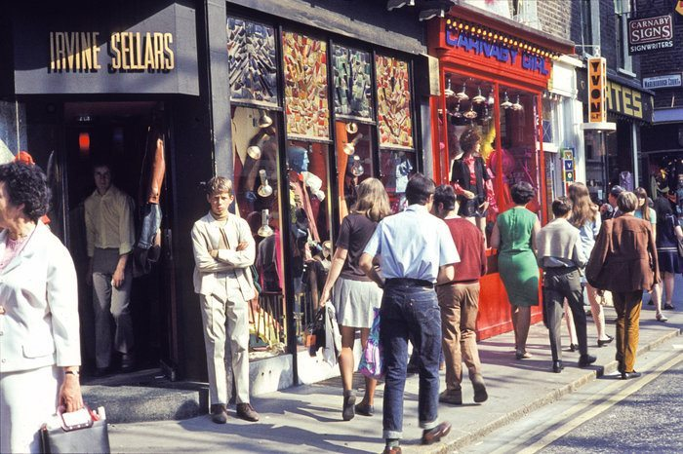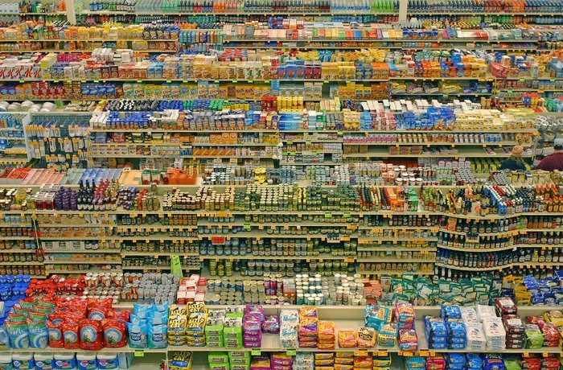

- Brainstorming
Cross-Pollination
- Combine a Cashier-less store with a Mini Hotel (both are cashier-less, paid with facial recognition system at each door)
- Combine a Cashier-less store with a Self-serve Restaurant (both are cashier-less, paid with facial recognition system at each door)
Constraint (Keep the same size) (Everything is paid with facial recognition system)
- Include a Cashier-less store, a Self-serve restaurant, and a Mini Hotel in a complex
- Still include a Cashier-less store, a Self-serve restaurant, and a Mini Hotel in a complex, but the Mini Hotel will be offered more privacy and the Self-serve restaurant will be offered more space.
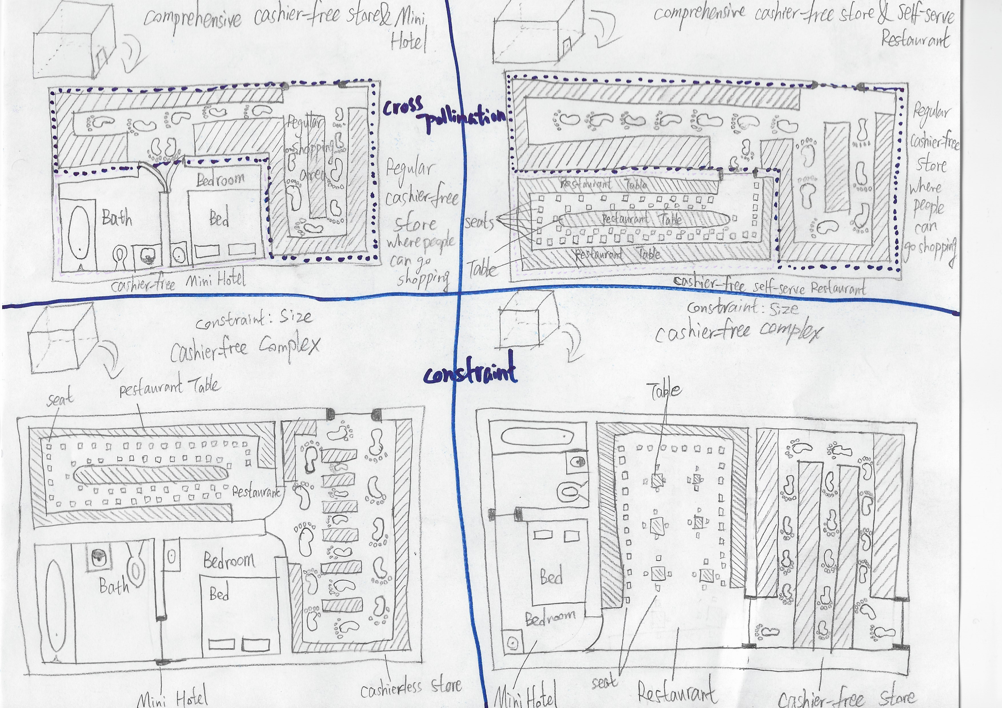
My preliminary sketches

- Initial Concepts
- Colourful Cashier-less Complex
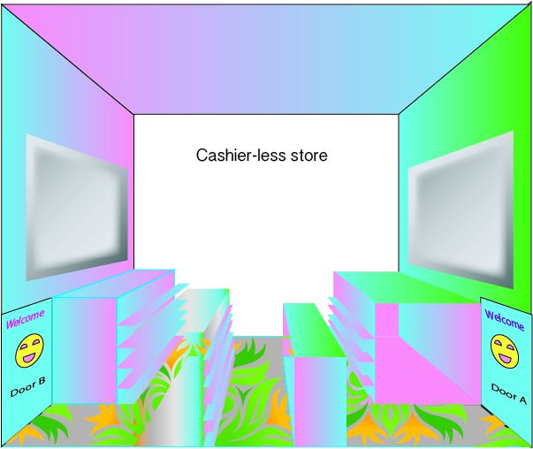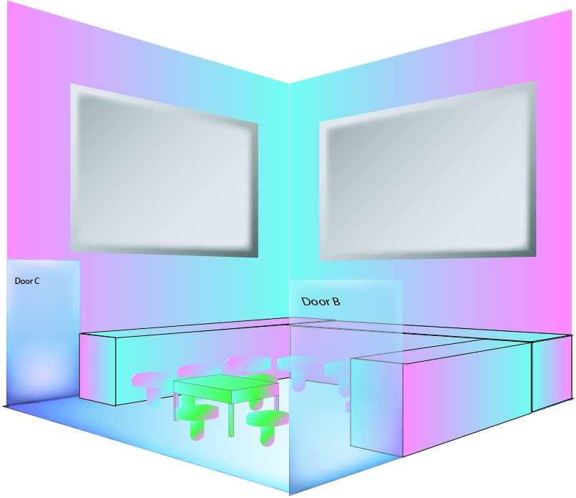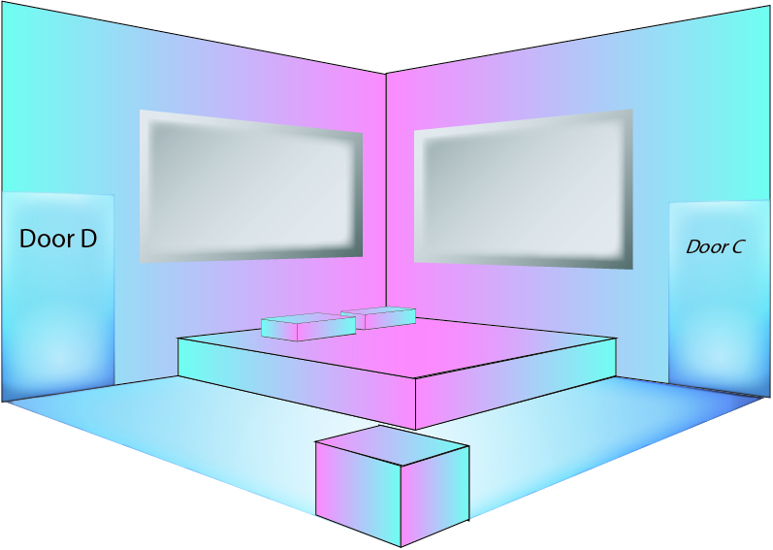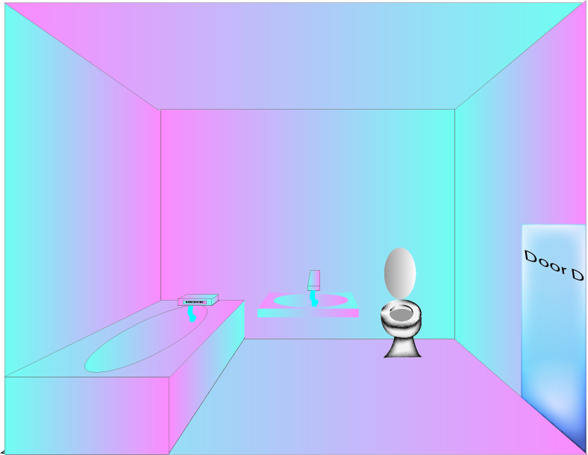
This look and feel is designed to be colourful, and is supposed to serve young people who usually stays here and/or nearby for hours and hours.
- Casual Cashier-less Complex
This look and feel is designed to be casual, and is supposed to serve visitors who come to a new city with relatively low costs and/or visitors who only stays here for a few hours.
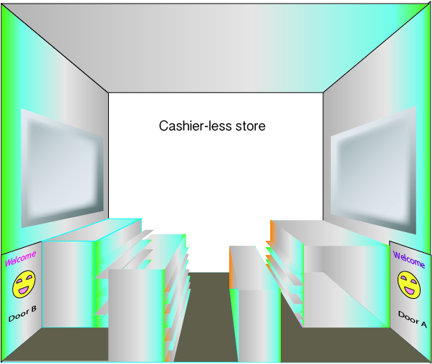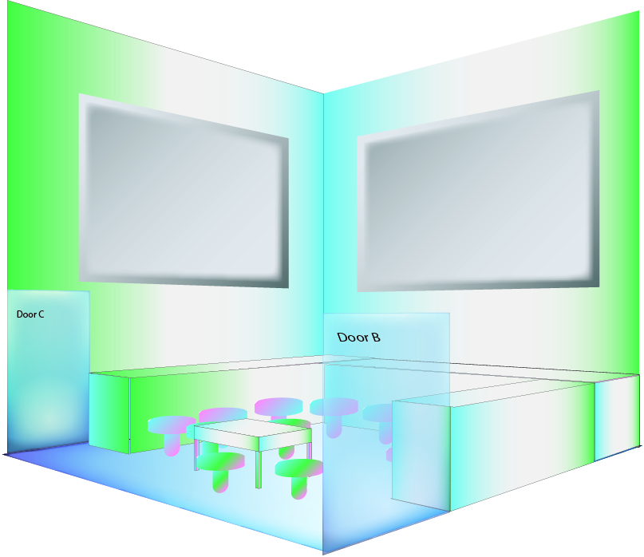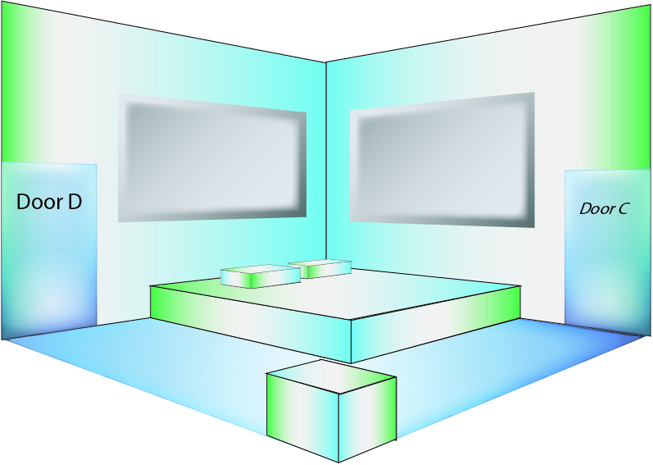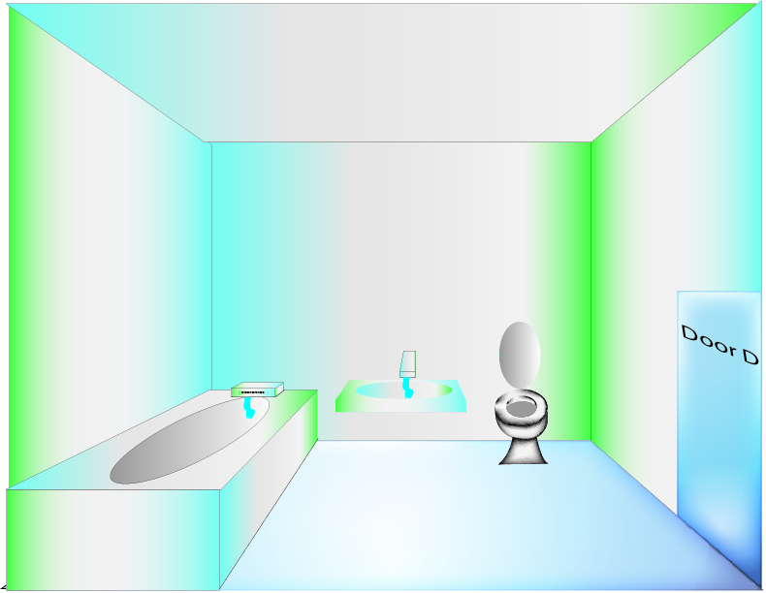
- Brand Names
- Colourful Cashier-less Complex: 1. Relax World 2. Easy-Come-Easy-Go
- Casual Cashier-less Complex: 1. Nest 2. Just-Come

Bibliography
Amazon. (n.d.). Frequently Asked Questions. Retrieved from Amazon: https://www.amazon.com/b?node=16008589011
Horwitz, J. (2018, January 22). China is both ahead of and behind Amazon in cashier-less stores. Retrieved from QUARTZ: https://qz.com/1185081/amazon-go-china-is-both-ahead-of-and-behind-amazon-in-cashier-less-stores/
Leibowitz, J. (2013, June 7). How Did We Get Here? A Short History of Retail. Retrieved from LinkedIn: https://www.linkedin.com/pulse/20130607115409-12921524-how-did-we-get-here-a-short-history-of-retail
OutsourcedClientSolutions. (2016, April 4). A brief history of retail. Retrieved from OutsourcedClientSolutions: https://www.ocsretailsupport.co.uk/latest-news/brief-history-retail/#highstreethysteria
Statt, N. (2017, February 6). Amazon’s cashier-free Go stores may only need six human employees. Retrieved from theverge: https://www.theverge.com/2017/2/6/14527438/amazon-go-grocery-store-six-human-employees-automation
Sun, Y. (2017, June 16). In China, a Store of the Future—No Checkout, No Staff. Retrieved from MIT Technology Review: https://www.technologyreview.com/s/608104/in-china-a-store-of-the-future-no-checkout-no-staff/
Suning Holdings Group. (2017, November 10). Suning to Open Four New Unmanned Stores in China. Retrieved from cision: https://www.prnewswire.com/news-releases/suning-to-open-four-new-unmanned-stores-in-china-300553764.html

